AI Probe Book
Purpose:- The AI Probe Book is a management platform tool designed to create, add, monitor, and control AI-driven chat conversations which we will use for product-related research and surveys.

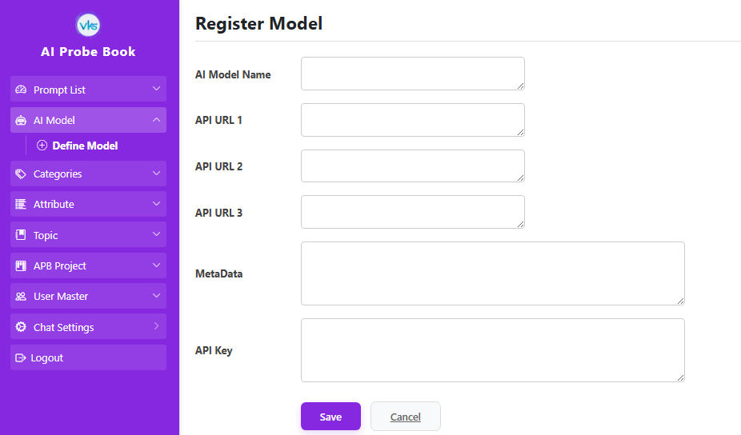
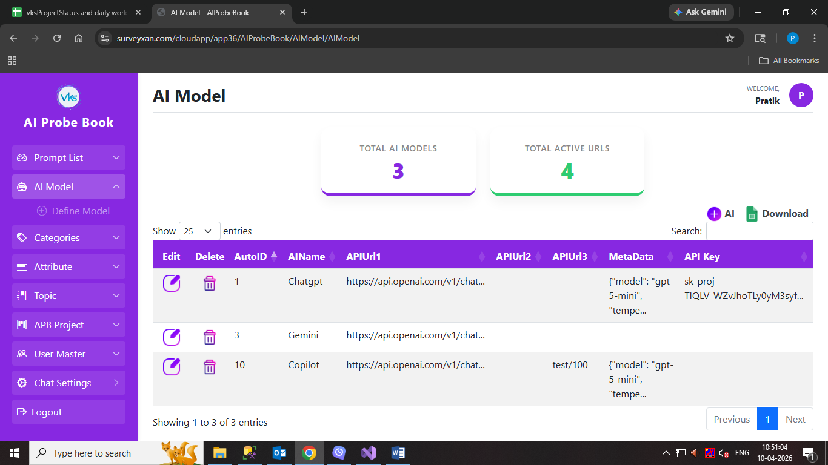
AI Model:

AI Model Purpose: The purpose of the AI Model module in application is to serve as a Management Bridge between software and various Artificial Intelligence providers (like Chatgpt, Gemini..).
Instead of hard-coding a single AI app, this module allows you to plug in, switch, and configure different models dynamically.
The top of the screen provides a quick summary:
- Total AI Models: Shows the total count of AI Models stored in the database.
- Total Active URLs: Shows the total count active URLs.
When registering a new model, the following fields are required:
- Name: The display name of the model like ChatGPT,Copilot, Gemini or any new AI model.
- API URL 1: The primary Urls. where the system sends chat requests.
- API URL 2/3: Secondary/Backup URLs. Used if URL 1 fails. (yet not implemented if require then can use API2/3)
- Meta Data: Store in JSON format. It Mandatory to defines the behavior (Temperature, Max Tokens, Model ID) for that specific AI.
  - How it Works: The AIChatController page sends a Model ID to the ChatAPI. The ChatAPI then uses that ID to find three things: API URL 1, Metadata, API Key.
If the API URL1, Metadata, or API Key is not exists then will display error: "Error: Could not get a response from the AI."
- API KEY: Authentication Token. The secret key provided by the AI vendor to authorize requests.

System Workflow
- Data Validation (The Save Button):
When you save button clicked, the application check Name, API URL1, MetaData and API key are all filled. If any are missing, the system triggers the "Required Field" alert.

- Data Maintenance (Edit & Delete):
Edit: Selecting a row and clicking the edit icon it reloads that specific model’s data into form
Delete: Permanently removes the model.

- Download Excel:
The "Download Excel" feature pull the current grid data into a spreadsheet.

Categories:
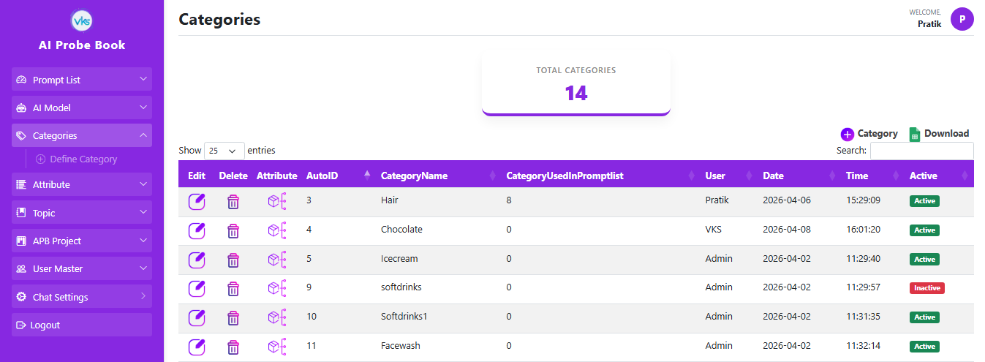

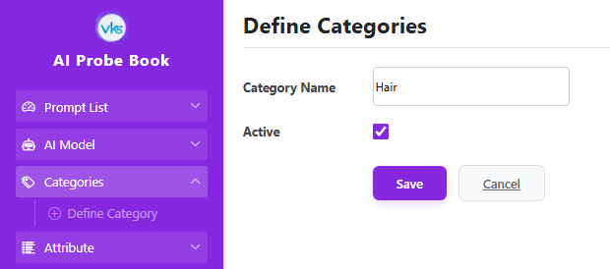

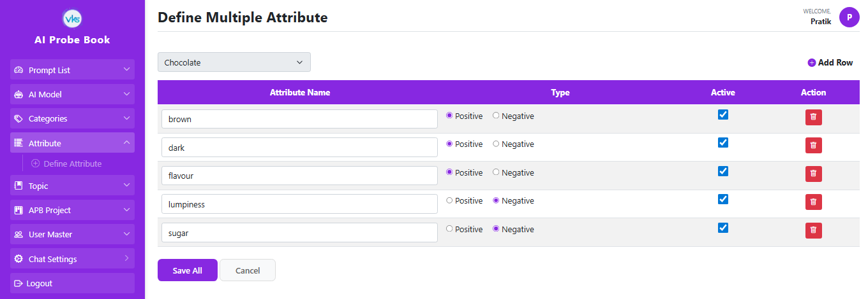

Category : It is a type of product on which survey or chat conversation required like Biscuits, haircare, Chocolate etc.
Purpose: To get chat conversation on selected Category itself
The top of the screen provides a quick summary:
Total Categories: Shows the total number of categories saved in the database.

System Workflow
- Data Validation (The Save Button):
When you save button clicked, the application checks if the Category Name is filled. If it is empty, a "Required Field" alert pop up. Category name would be unique.

- Data Maintenance (Edit, Delete):
Edit: When you click on edit icon load the category details into the form so you can change the name.
Delete: It checks two things before deleting:
- It checks if the category is linked to any Attributes.
- It checks if it is used in the Prompt List.
You must delete the associated Attributes and Prompts first before the system will allow you to permanently remove the Category.

- Attribute Management:
When you click the Attribute icon on a category, it allows you to define attribute details for specific category. Add Attributes for Specific category.

Attribute Grid:
- Attribute Name: Enter attributes here. You can add multiple attributes separated by commas (e.g., for the Mobile category, you can enter: Screen Size, Battery, Performance).
- Type: Define if the attribute is Positive or Negative.
A positive attribute is a quality or feature of a product that customers like or appreciate like for biscuit category its delicious, crunchy, melting etc
  - A negative attribute is a quality or issue that customers dislike or complain about like for biscuit category too sweet, too buttery, Expensive etc
- Action: Allows you to remove a specific row from the list.
- Saving Logic: When you click Save, the system automatically delete the old list for that category and replaces it with your new, updated list of attributes.

- Download Excel:
The "Download Excel" feature pull the current grid data into a spreadsheet.

Attribute Part is being Repeated mention in category

Attributes:
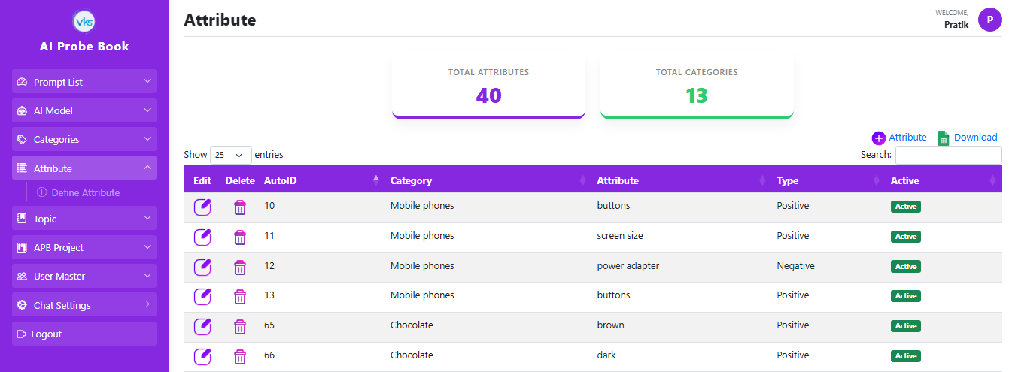
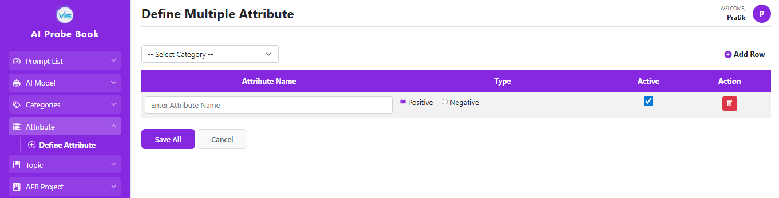

Attribute Purpose: The Attribute Module is used to define the features associated with a specific category. These attributes help the questions or logic for the AI.
The top of the screen provides a quick summary:
Total Attributes: Shows the total number of attributes saved in the database.
Total Categories: Shows the total number of categories saved in the database.

System Workflow
1. Data Validation (The Save Button):
When you click the Save button, the system checks:
- Category Selection: You must select a category from the dropdown.
- Minimum Entry: You must enter at least one attribute name.
If either check fails, a "Required Field" alert will pop up.

2. Data Maintenance (Edit, Delete):
Edit: When you click the edit icon opens the detailed for that category’s attributes.
The Category is Fixed: Because you clicked the edit icon for a specific attribute, the dropdown is "locked" to that category name and cannot be changed.

Attribute Grid:
- Attribute Name: Attribute Names: Enter attributes here. You can add multiple attributes separated by commas (e.g., for the Mobile category, you can enter: Screen Size, Battery, Performance).
- Type: Define if the attribute is Positive or Negative.
- Action: Allows you to remove a specific row from the list.
- Saving Logic: When you click Save, the system automatically delete the old list for that category and replaces it with your new, updated list of attributes.
Delete: Clicking the delete icon permanently removes that specific attribute from the database.

3. Download Excel:
The "Download Excel" feature extracts the current grid data into a spreadsheet.

Topics:
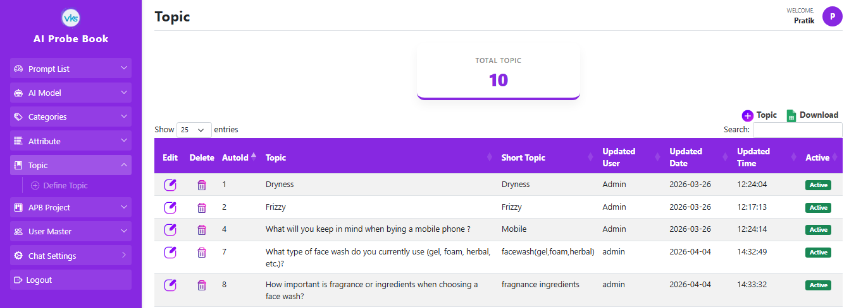

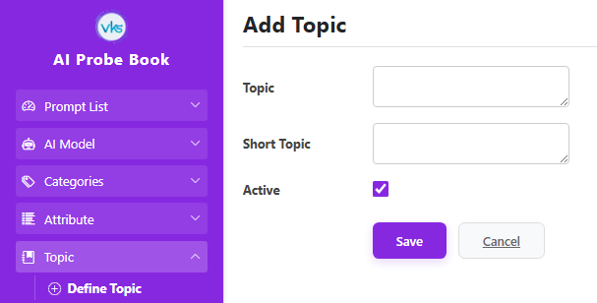

Topic Purpose: The Topic Module is used to define the specific question or subject that the AI will focus on during the conversation. While the Category defines "what" the product is, the Topic defines the "scenario" for the discussion.
For Example: If the category is Mobile Phones, the Topic might be: "What are the key factors to consider when buying a new smartphone?" This ensures the AI doesn't just talk about phones in general, but specifically helps the user with buying advice.
The top of the screen provides a quick summary:
Total Topic: Shows the total number of topic saved in the database.
System Workflow
1. Data Validation (The Save Button):
When you click the Save button, the system checks:
- Short Topic: A short name used for quick identification. This is displayed in PromptList as Topic
- Topic Name: The full, detailed question or instruction that describes the subject.
- Both are Mandatory to fill.
2. Data Maintenance (Edit, Delete):
Edit: When you click the edit icon opens the record, allowing you to modify the Short Topic or the full Topic Name.
Delete: it will not allow to delete when there is data integrity . Fisrt want to check its dependency in Prompt list remove those then will allow you delete.

3. Download Excel:
The "Download Excel" feature extracts the current grid data into a spreadsheet.

APB Project Details:
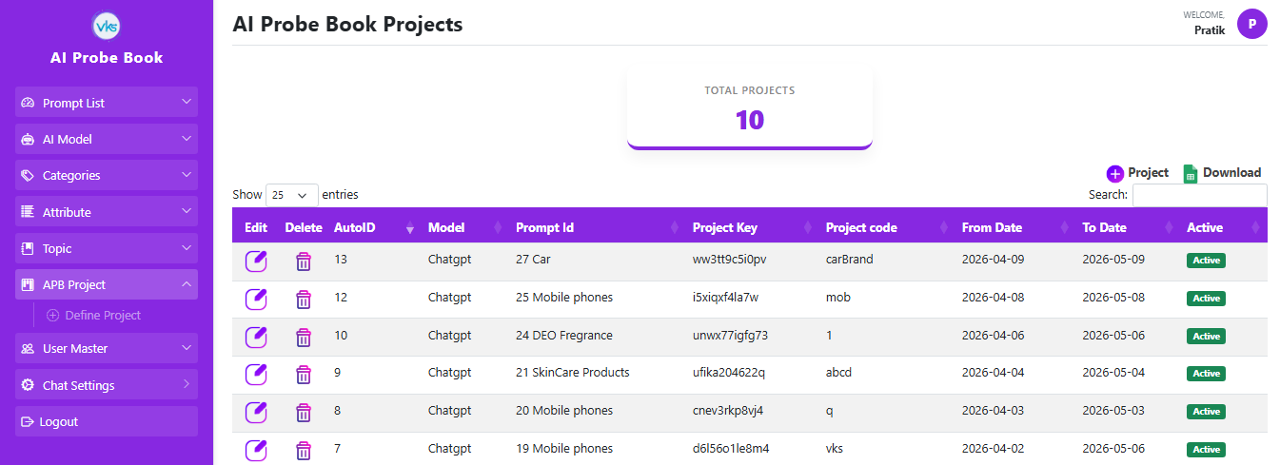

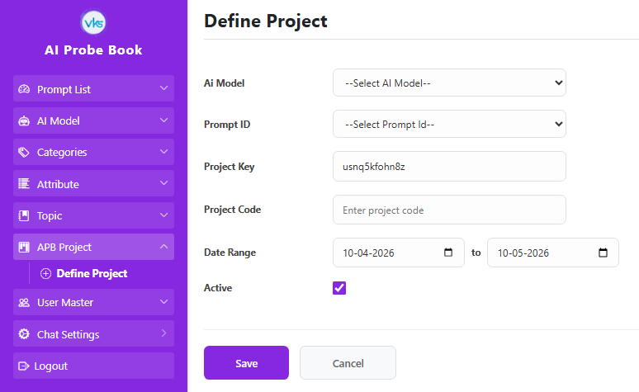

APB Project Details Purpose: The purpose of this module is Project Activation. A project must be defined and active here for the chat window to function.
If a user attempts to access the chat window but the project is not active or hasn't been created, the system will trigger a "Project is not created" alert and block access.
The top of the screen provides a quick summary:
Total Projects: Shows the total number of active projects saved in the database.

System Workflow
1. Data Validation (The Save Button):
When you click Save, the system acts as a bridge, linking data from other modules.
The following fields are required:
AI Model: Select an active model from the dropdown menu (sourced from the AI Model Module) to specify which model will be used for the project.
Prompt Id: Select the appropriate ID from the dropdown list (sourced from the Prompt List + Category Module).
Project Key: It is a unique, system-generated 12-digit alphanumeric key. This field is disabled because the system creates it automatically for security.
Project Code: A custom name or identifier entered by the user for the specific project instance.
Date Range: Defaults to a one-month duration, starting from today's date.
If any required fields (AI Model, Prompt ID, or Project Code) are missing, the system triggers a "Required Field" alert.

2. Data Maintenance (Edit, Delete):
Edit: Allows you to modify the project settings, including the AI Model, Prompt ID, Project Code, and Date Range.
Delete: Permanently removes the project.

3. Download Excel:
The "Download Excel" feature extracts the current grid data into a spreadsheet.

Chat Settings:
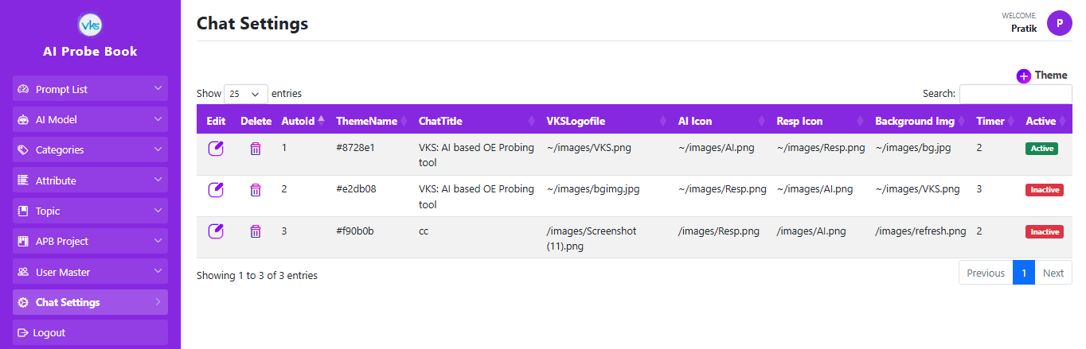

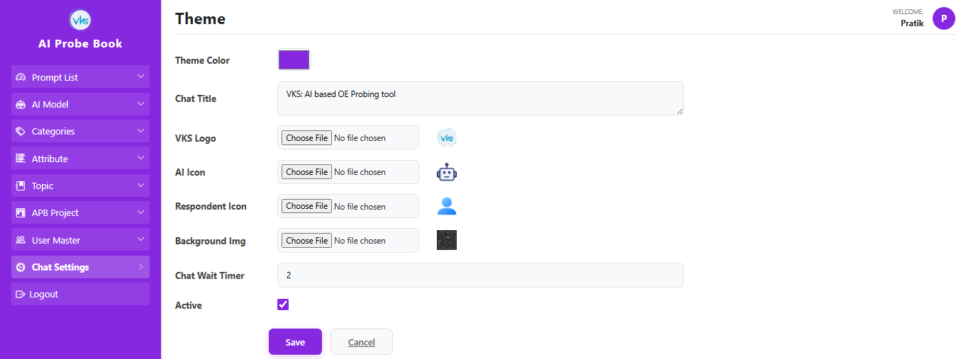

Chat Settings Purpose: The primary purpose of this module is Interface Personalization. It controls all the functional UI elements of the chat window. By adjusting these settings colors, logos, and background images.

System Workflow
1. Data Validation (The Save Button):
When you clicked on Save Button, the system ensures you provide following information:
Theme Color: Color Picker selection. Sets the color for the header and the "Send" button.
Chat Title: Displays the name in the header (e.g., " VKS: AI based OE Probing tool")
VKS Logo: The logo displayed in the top header.
AI Logo: The avatar icon that appears next to the AI's messages.
Respondent Logo: The avatar icon that appears next to the user's messages.
Background Image: The wallpaper that appears behind the chat bubbles.
Chat Wait Timer: Sets the timeout duration (in minutes). If the AI response or network connection exceeds this time, an alert appears: “The AI is taking a while. Do you want to keep waiting? Click 'Ok' to reset.” Clicking OK will reset the chat
If you click Save while either of these fields is empty, the system will trigger a "Required Field" alert.

2. Data Maintenance (Edit, Delete):
Edit: Opens the existing theme record. This allows you to update logos or change the theme color to match a new project style.
Delete: Permanently removes the project.

3. Download Excel:
The "Download Excel" feature extracts the current grid data into a spreadsheet.

Prompt List:
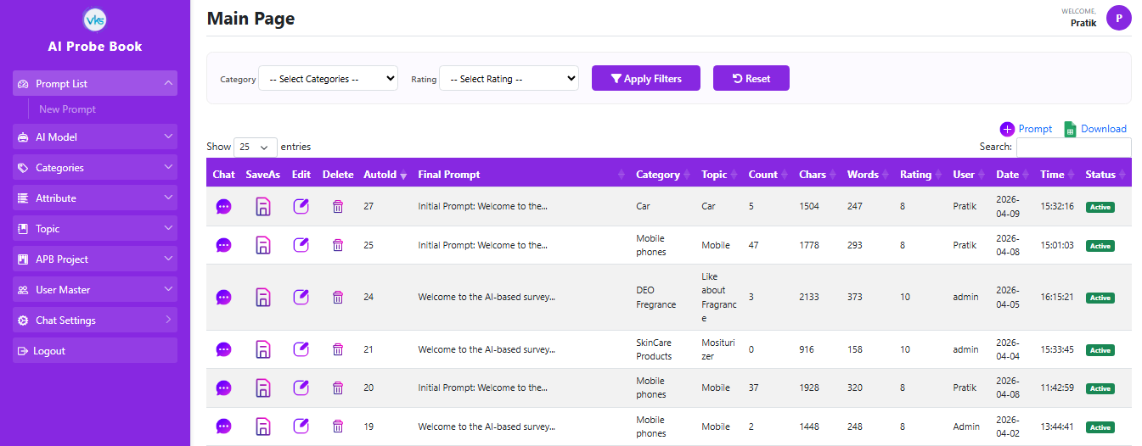

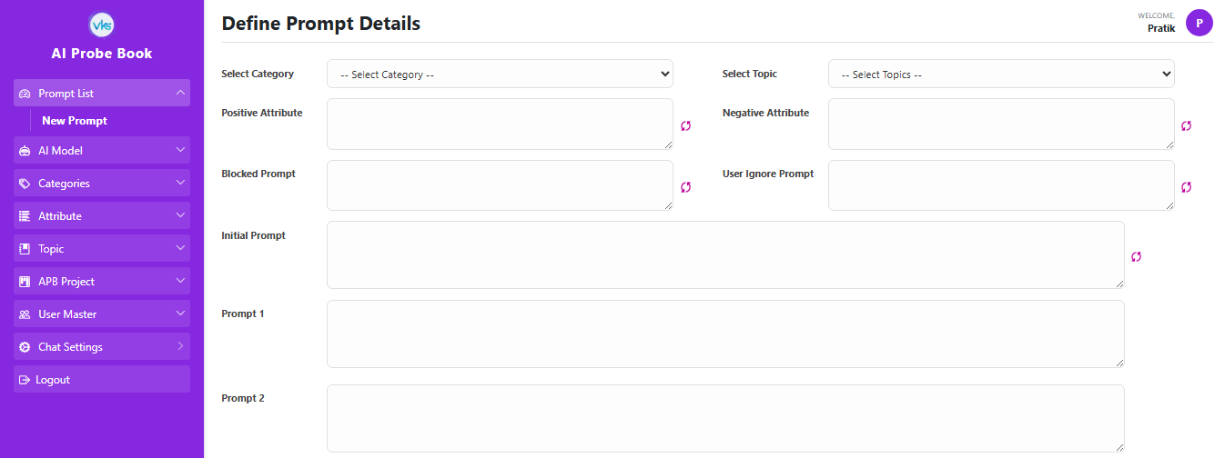

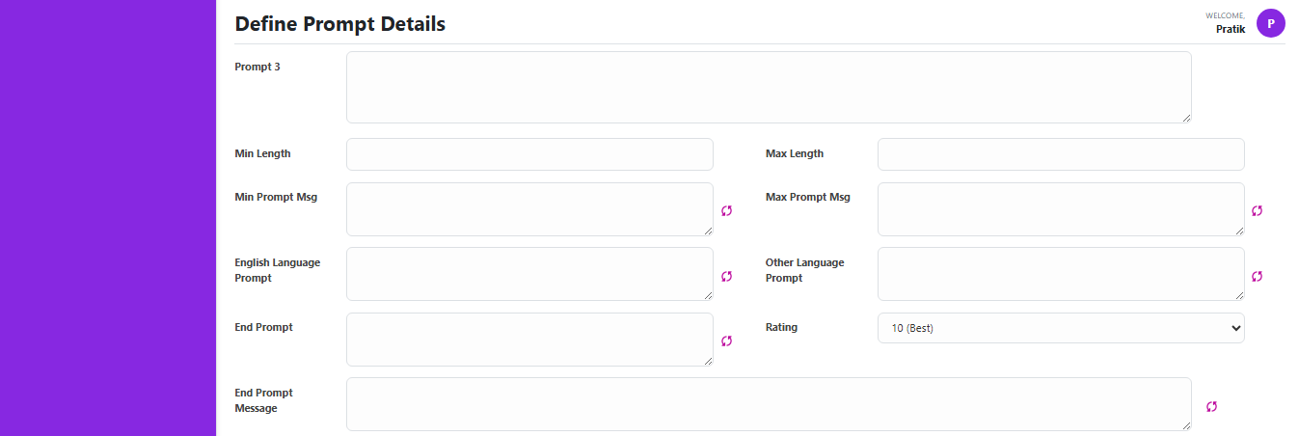

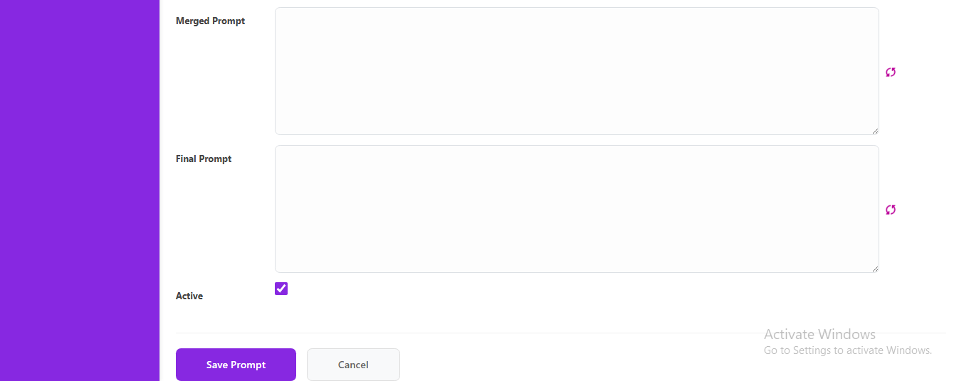

PromptList Purpose: This is the main module where we will pass all type of prompts to get best and required chat conversation which we will save in our side and later among the best Chat conversation prompt get selected and displayed to client

System Workflow
1. New Prompt:
- Select Category: Select the category Name from the dropdown list (sourced from the Category Module).
- Select Topic: Select the topic Name from the dropdown list (sourced from the Topic Module).
- Positive Attributes: When clicking AutoGen, the system retrieves all "Positive" records from the Attribute Module linked to the selected category. If multiple attributes exist (e.g., flavor, brown, dark), they are automatically populated in the textbox separated by commas. These guide the AI on what questions to ask to highlight strengths.
- Negative Attributes: When clicking AutoGen, the system retrieves all "Negative" records from the Attribute Module linked to the selected category. If multiple attributes exist (e.g., Price, sugar, quantity), they are automatically populated in the textbox separated by commas. These guide the AI on what questions to ask to highlight strengths.
- Block Prompt: It is basically a list of not allowed topics. It gives the model a clear set of not allowed topics. On what topics AI Model will not ask questions .
- User Ignore Prompt: Instructions for the AI to ignore irrelevant user answers. If a user provides a non-related response, the AI is forced to redirect the conversation back to one of the category attributes.
- Initial Prompt (ID: 1): This is initial Prompt (e.g., "Welcome to our survey..."). In this survey, It tells the AI who it is and what it should talk about. It uses a "Search and Replace" system to fill in the blanks with your project details. I have set the Initial ID to 1. When you click the AutoGen button, the system goes to the PromptTemplate table. It looks for ID 1 and copies the text from the Message column. The text inside the database has four special symbols. The system automatically replaces these symbols with the information you selected on your screen:
  - {C} (Category): The system removes {C} and puts in the Category you chose from the dropdown list.
  - {T} (Topic): The system removes {T} and puts in the Topic you chose from the dropdown list.
  - <+> (Positive): The system removes <+> and puts in all the Positive Attributes from your textbox.
  - <-> (Negative): The system removes <-> and puts in all the Negative Attributes from your textbox.
Example: "Welcome to the AI-based survey you should ask questions related only to {C}. Focus on the topic {T}. Ask questions about <+> and check for problems like <->." |
After you click AutoGen: If your Category is "Mobile" and your Topic is "iPhone," the message becomes:
"Welcome to the AI-based survey you should ask questions related only to Mobile. Focus on the topic iPhone. Ask questions about Battery, Camera and check for problems like Heating, Slow Charging."
- Prompt 1/2/3: These fields allow for the inject extra instructions. They provide flexibility to add extra context without disrupting the logic of the main Initial Prompt.
- Min/Max Length: These are integer fields where you define the minimum and maximum number of questions the AI should ask.
- Min Prompt Msg (ID: 5): I have set the Initial ID to 5. When you click the AutoGen button, the system goes to the PromptTemplate table. It looks for ID 5 and copies the text from the Message column and replaces the {} placeholder with the value from the Min Length box. (e.g., "Ask at least {} questions" becomes "Ask at least 5 questions").
- Max Prompt Msg (ID: 6): I have set the Initial ID to 6. When you click the AutoGen button, the system goes to the PromptTemplate table. It looks for ID 6 and copies the text from the Message column and replaces the {} placeholder with the value from the Max Length textbox. (e.g., "Please do not ask for more than {} questions." becomes "Please do not ask for more than 10 questions ").
- English Language Prompt (ID 12): A strict instruction set retrieved via AutoGen that forces the AI to communicate only in English, even if the user attempts to reply in another language.
- Other Language Prompt (ID: 13): This handles "transliteration" logic. You will ask 1st question in English. If a user types a non-English language using English characters, the AI is instructed to detect this and respond in a similar, natural language.
- End Prompt (ID: 2): The final instruction to the AI on how to end the survey and say Thank you.
- End Prompt Message (ID: 9): This is a System Comparison Key.
The application compares the AI's final message to this specific text. If they match, the system automatically hides the Typing Indicator and Send Button, and displays a "Conversation Closed" message to the user.
- Merge and Final Prompt: The Final Step. The Merge Prompt and Final Prompt are the most important fields in the module. They act as the "Master Prompt " that are sent to the AI to start the conversation.
I have set ID 6 for the Merge Prompt.
I have set ID 7 for the Final Prompt.
When you click the AutoGen button, the system collect every single piece of information you have entered in the other fields.
The system takes all the following data and joins them together into one long list of instructions. Each item is placed on a new line to make it clear for the AI:
- Initial Prompt: (The one with Category and Topic)
- Prompt 1, Prompt 2, and Prompt 3: (Extra instructions)
- Min Max Length Messages: (How many questions to ask)
- English & Other Language Prompts: (Language rules)
- End Prompt & End Prompt Message: (How to finish)
The Merge Prompt textbox is Read-Only. Its only job is to show you exactly what the combined message looks like after you click AutoGen. This allows you to review the full instruction before the session starts.
The Final Prompt is the actual string sent to the AI API. Because all the rules are combined here on new lines, the AI receives a complete "manual" on how to behave. In case want to change prompt can be done in Final prompt it is editable. It knows:
- What product it is talking about.
- Which attributes to ask about.
- How many questions to ask.
- What language to use.
- How to end the chat.
By merging everything into one string, we ensure the AI doesn't get confused and follows all project rules from start to finish.

2. Save As Button: Quick Project Creation.
The "Save As" button is a time-saving feature designed to help you create new projects quickly when you only need to make small changes to an existing one.
You don't have to select the Category or Topic again. You don't have to click every "AutoGen" button one by one.
This is perfect for when you have a working prompt that is 90% perfect.
Instead of spending 5 minutes setting up a new prompt from scratch, you can create a new project in just a few seconds.
- How it Works: When you are looking at an existing prompt, you can click the Save As button.
The system instantly copies all the information from the current prompt (Category, Topic, Attributes, & all merged messages). It then opens a New Prompt Page with all those details already filled in.
When you click Save, it saves the information as a new entry in the database. It does not overwrite the old project.

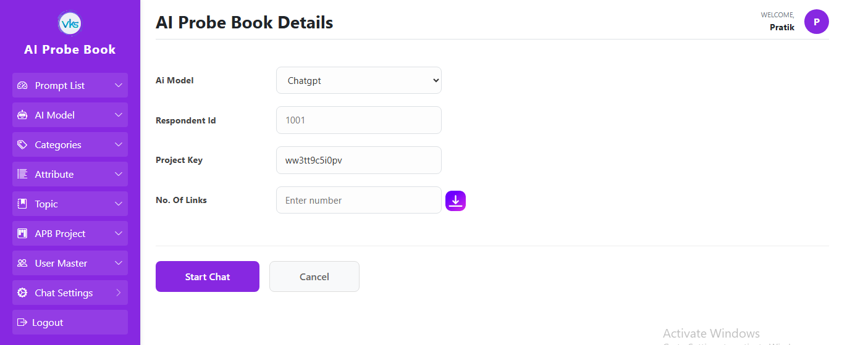

3. Chat Button: When u clicked on the chat button of that prompt. It will check the project is created for that prompt, if not then it will comes error “Project is not created”.If it is created, The Chat Window page is open. On that there are 4 fields
- AI Model: This is know the which model is used for that prompt. It is disable means u cannot change because it define when u setting up (APB_ProjectDetails) table for that prompt.
- Respondent Id: This is mandatory. It shows the what is the respondent id for that.
- Project Key: The Project key comes auto and it will be disable because it is created when u creating the project for that Prompt.
- No. of links: it is non mandatory, Its working is what u enter number and click on the download btn. It will check the number what u enter in a no. of links and check the respondent id is enter or not.
if the No. of links entered nuber is 5 and the respondent id entered 1001 and click on the download btn it wll create the 5 links and attached in a excel and it will download. The links is “https://surveyxan.com/cloudapp/app36/AIProbeBook/AiChat/Index/ww3tt9c5i0pv/1001.”

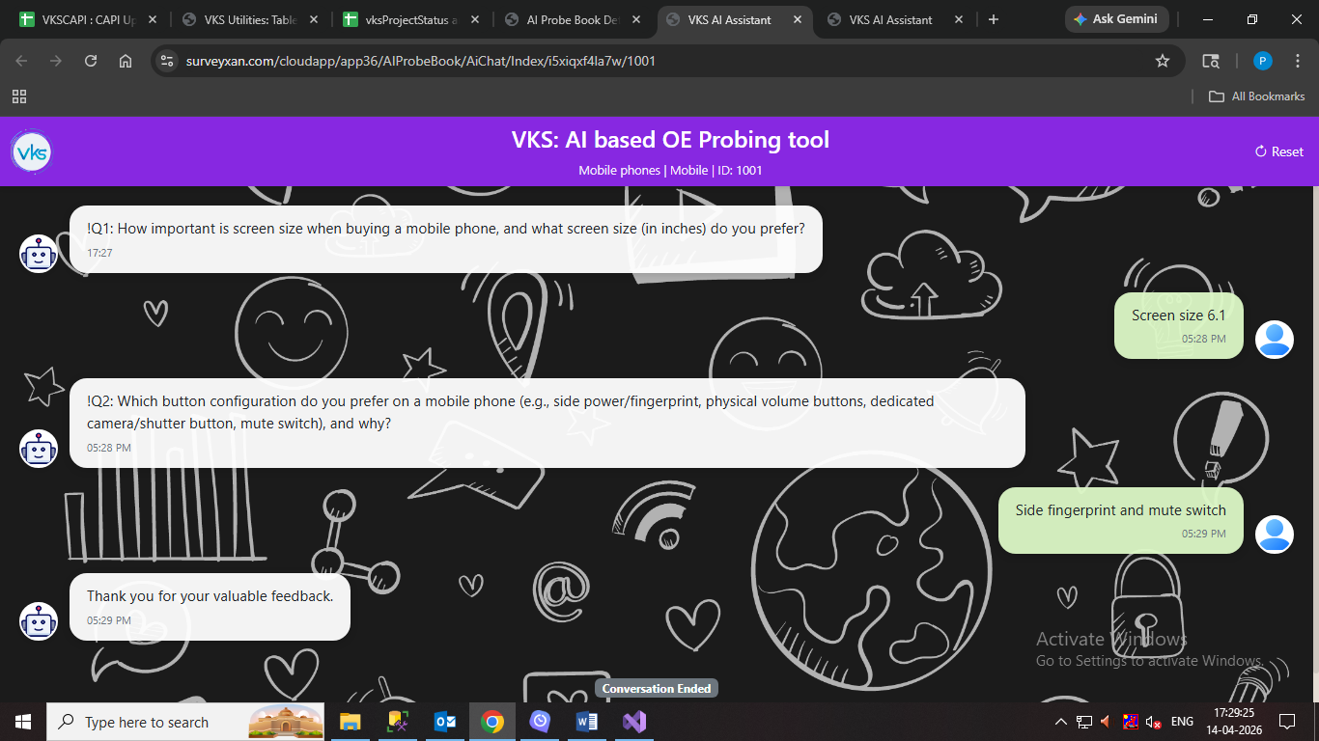

3. Start Chat: The Start Chat function is the most complex part of the system. It handles everything from checking project validity to communicating with the AI.
A. Security and Validity Checks: Before the chat screen opens, the system performs two main checks:
- Project Activation: It checks if the ProjectKey is currently active.
- Date Validation: It looks at the FromDate and ToDate in the AIProbeBook_ProjectDetails table. The chat will only start if the current date is within this valid range.
B. UI Customization (Theme Loading): Before the chat screen opens, the system performs two main checks:
- If the project is valid, the system loads the settings from the ChatSettings table (where Active = 1).
- It automatically applies:
  - Logos: Header logo, AI icon, and Respondent icon.
  - Visuals: Background image, colors for the header and send button.
  - Header Text: The system fetches the Category, Topic and Title names to display them on the chat header.
C. Session Initialization: Once the UI is ready, the system runs an Insert Query into the ChatSession table to track the new conversation.
It records:
- Respondent ID, Project Code, and Prompt ID.
- Start Time, Date, and the Final Prompt.
- Model ID (which AI model is being used).
D. AI Communication Flow (The API Logic): The system uses a specific structure to talk to the AI.
- System Role: The very first message sent to the AI is our Final Prompt. This is assigned the role of "system" so the AI knows these are its instructions.
- UserRequest Class: Every request to the AI must have two properties: Role (who is speaking) and Content (the message text).
- ChatAPI Processing: The system calls the GetBotResponse method. It looks up the ModelId in the AIModel table to get the MetaData, API URL, and API Key. If the API Key and MetaData are valid, the AI provides a response. If not, the system returns an "Error from OpenAI Provider" message.
- Conversation Saving: Every AI question and every User answer is saved into the ChatConversation table to maintain a full history.
E. Ending the Conversation: The system automatically check when to stop the chat: The system compares the AI's last message with the End Prompt Message. If they match, the "Conversation Closed" message appears, and the typing indicator/send button are hidden. The system runs the UpdateSessionEnd method to save the Total Word Count, Total Character Count, and the exact End Time.
F. Chat Wait Timer Logic: The timeout feature stops the AI if it takes too long, so you don't have to wait. This only works if isTimer is set to Active in the Chat Settings.
- Working:- When the user clicks "Send," a timer starts (using the minutes defined in Chat Settings). If the AI takes too long to respond, an alert appears: "The AI is taking a while. Do you want to keep waiting? Click 'Ok' to reset." If the user clicks Cancel, nothing happens. If the user clicks OK, a new record is added to the Chat Session table, and the word "reset" is added to the Remarks column for tracking.

